Alex Brough

Newcastle and Stafford Colleges Group  [Company address]

Alex Brough

Newcastle and Stafford Colleges Group  [Company address]

Contents

HOME PAGE 2

Time and Venue page 3

BOOKING PAGE 4

Test stratergy 5

# Site Map

# HOME PAGE

This is the home page for the pure media “THE STIG OF METAL” event

I have created a top bar to easily Navigate though all the information on the website, the pure media logo would be the link to the home page as this is a norm in other websites I have researched, the other links on the top bar are there for fast and easy use of the website meeting all the page requirements of the brief .

Underneath the top bar I have added and image of the stig the main star of the show enticing the user of the website and a clear title over the image showing the event name , the main star and a question for the visitor creating excitement for the show

A book now button is placed near the top of the page allowing users to give a quick booking response increasing the likelihood users would get to the booking page and book events.

Underneath I have a second image section where I am promoting the improvement of the events over previous years improving user views on the event. With a large title for the section I draw the users attention and highlighting important words in yellow the accent color allowing for easy and quick understanding of the information.

Underneath I have added the albums that will be played allowing people to gather information about what music is played there

Finally I have produced a footer for the page proving all the neccesary information including navigation links to other parts of the website if the user has reached the bottom without having the information they need

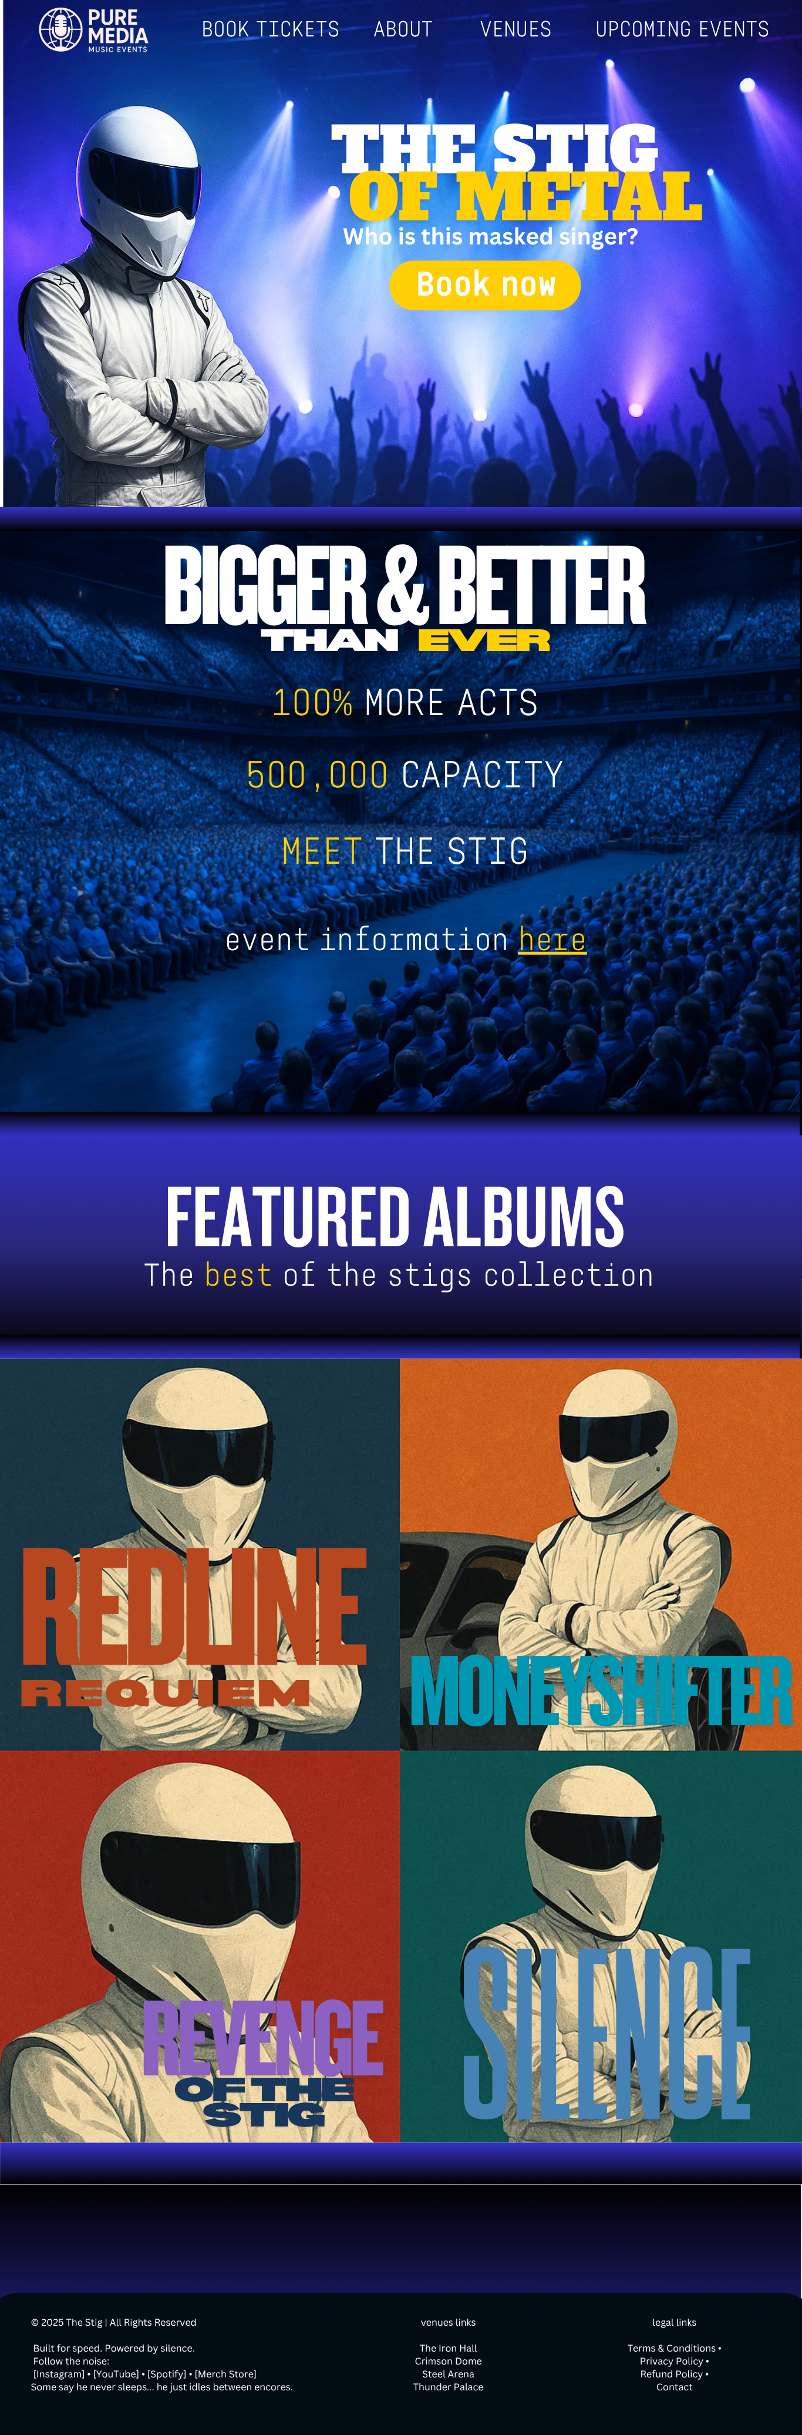

# Time and Venue page

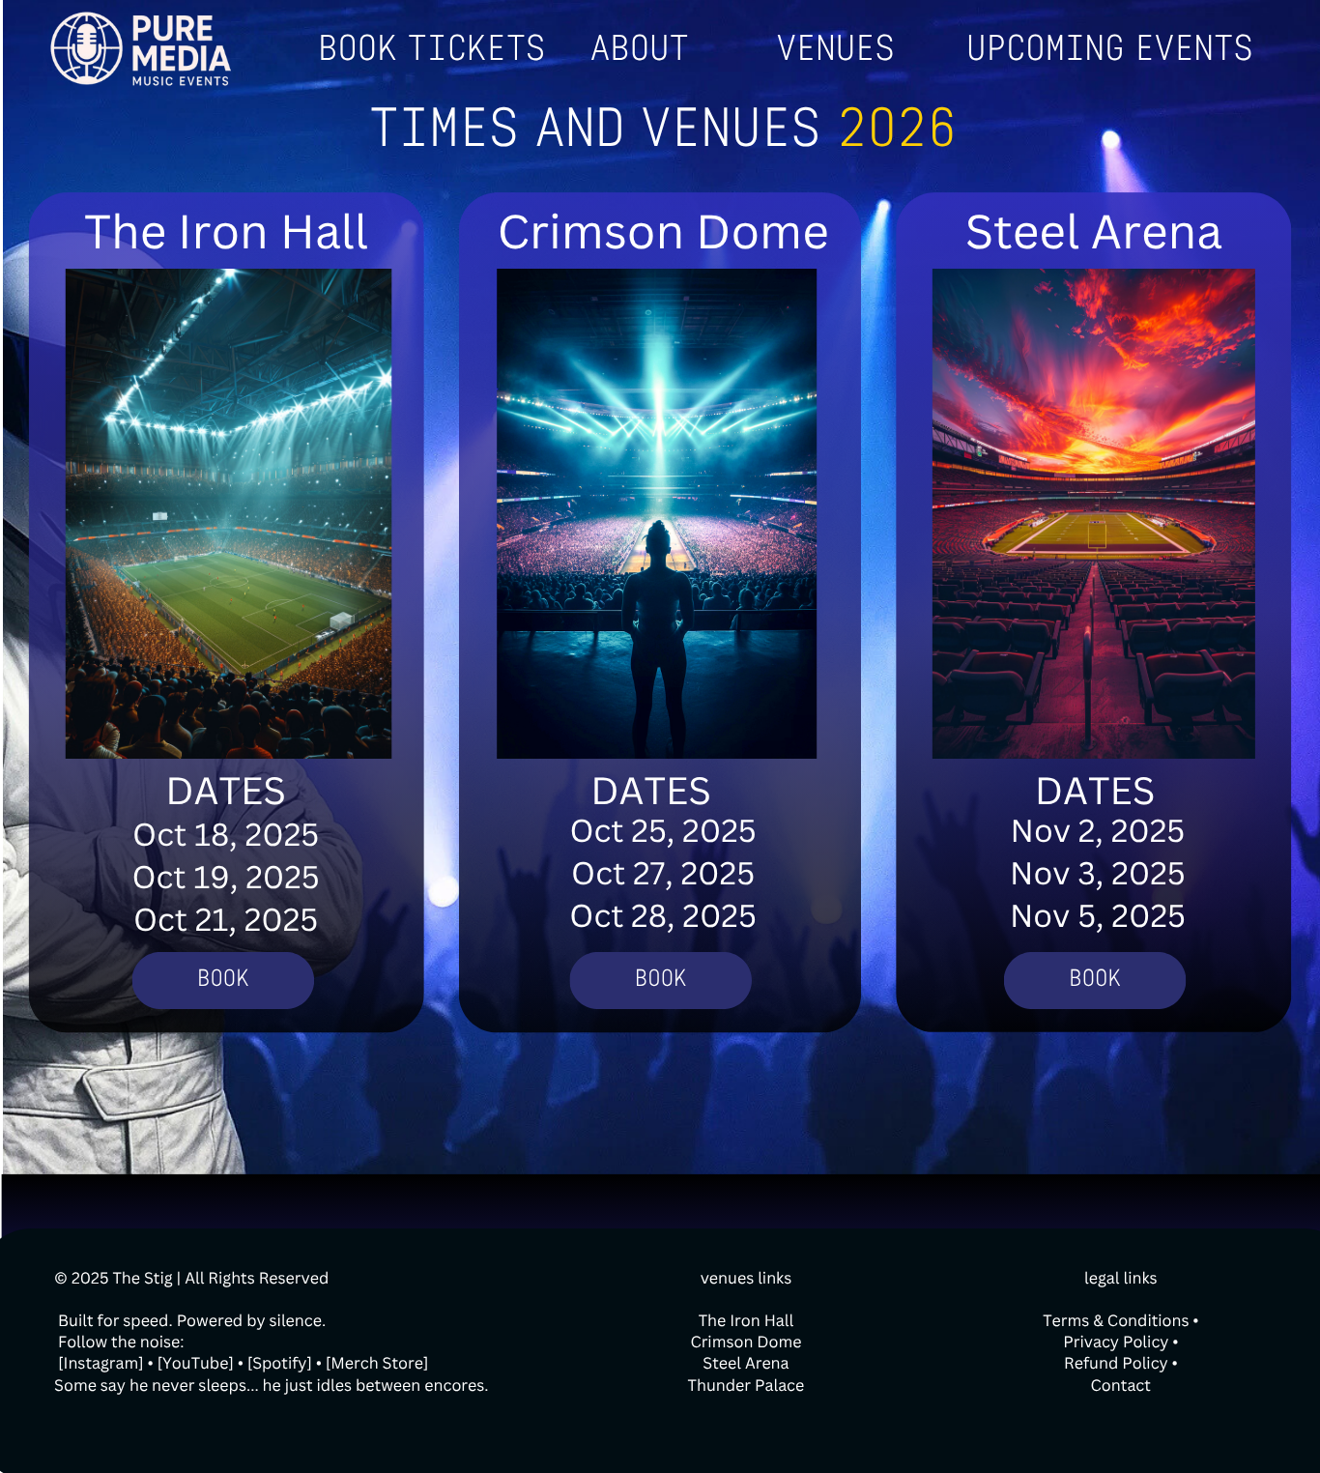

This is the times and venues page which provides information on the dates and venues each event is being held on. This informaytion is made to be easy to read and quick links to booking allows for easy flow though the website.

The top navigation bar is consistent with the rest of the website for easy navigation along with the footer also being the same.

The background is consisent with other pages theming for visual appeal

BOOKING PAGE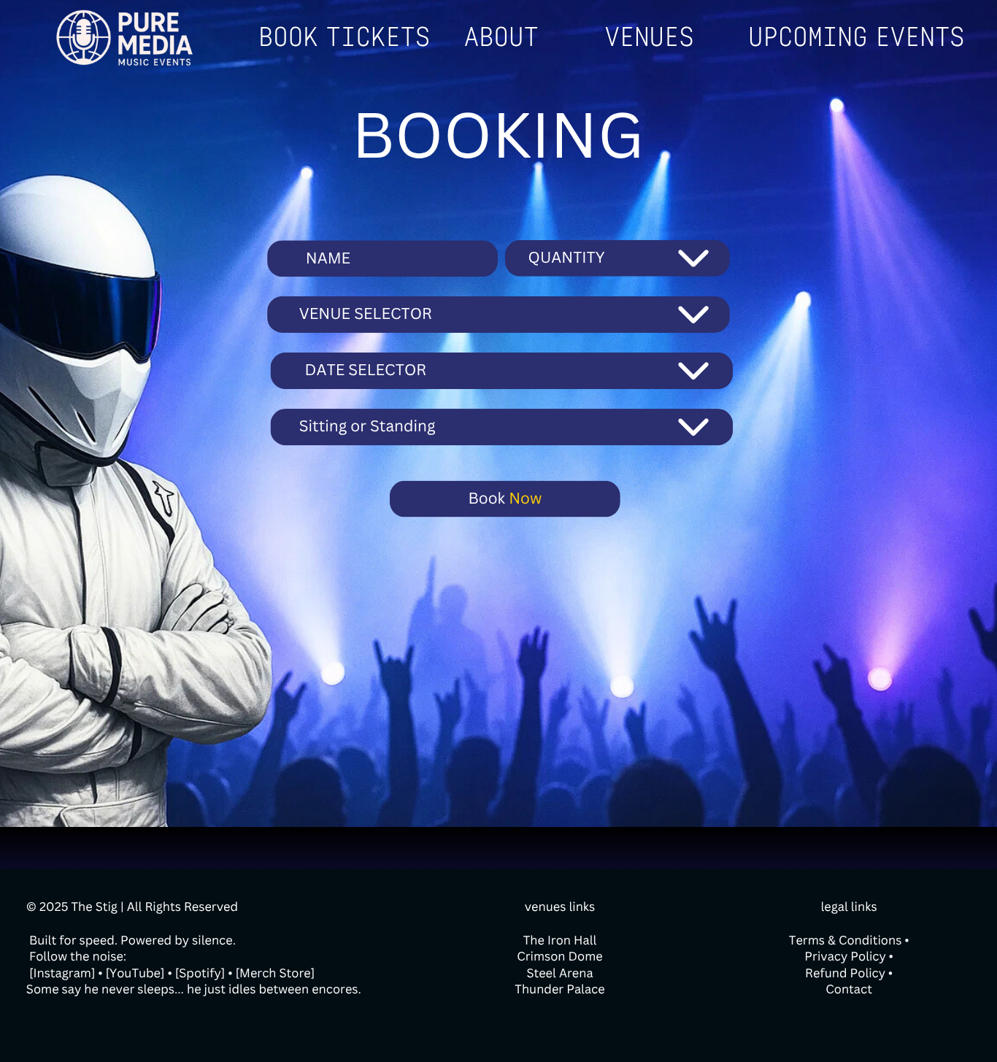

This is the booking page for the website, I have kept the footer and nav bar consistent from the rest of the website for easy navigation.

On the booking page I have provided a booking title which allows the user to know what page they are on easily.

I then I have fields of name,quanitity,venue selector , date selector, and sitting or standing

These values are in drop downs apart from name to minimise erorrs and make the form easier to use.

And I have provided a book now button to submit the booking request.

The background is consisent with other pages theming for visual appeal

# Test strategy

|  |  |  |  |
| --- | --- | --- | --- |
| Date of test | Component to be tested | Type of test to be carried out | Preriquesites and dependencies |
| 01/01/2025 | Homepage navigation bar | Valid-test out all the links for the other pages | The top bar must be complete and other other pages must exist with the top bar coplete them. |
| 01/01/2025 | Page links | Valid- test find out more information button works correctly | The more information page should exist and the link text should be on the page |
| 01/01/2025 | Footer links | Valid-test if the links to socials on the footer work along with links to the legal information works | Footer |
|  |  |  |  |
|  |  |  |  |
|  |  |  |  |
|  |  |  |  |
|  |  |  |  |

# testing

|  |  |  |  |  |
| --- | --- | --- | --- | --- |
| Description of test | Test data | Expected outcome | Actual outcome | Changes made |
| Testing the top bar links to other pages | clicking | Navigate to and from pages | Successfully navigated | None |
| Testing if the logo displays properly | Logo.png | Logo displays nicely | Logo too large | Logo decreased in size |
| Testing if the logo displays properly | Logo.png | Logo displays nicely | Logo displays correctly | none |
| Testing if the title of the hero section displays correctly | none | Title is a nice size and readable placed nicely | Text is off to the side and too small | Increased text size and centred the div |
| Testing if the title of the hero section displays correctly | none | Title is displayed correctly | Title is the correct size and centred | none |
| Testing if the subheading and the button is placed correctly and the right size | none | Button and subheading is correct size | Button and subheading are correct size | none |
| Testing button works correctly | none | Book now button takes to booking page | Button works as expected | none |
| Testing if bigger and better section displays correctly | none | Text should be readable and no typos | Title is right size but the p text size is too small | Changing the p font size |
| Testing featured album works correctly | none | All information shows correctly | Title does not appear | Title was wrong colour changed to white |
| Testing if the grid scales correctly of the albums | none | Grid should deform based on the size of the page | Deforms correctly but slightly to small on mobile | Enlarged mobile styles |
| Testing if the footer displays correctly | none | Footer should appear at the bottom of the page, and it should have all the information on it | Footer appears but font is too small and the wrong colour | Changed colour to white and increased font size |
| Testing footer links | none | Footer links should take to the relative pages | Footer links don’t work and show outdated information | Update the footer information |
|  |  |  |  |  |
|  |  |  |  |  |
|  |  |  |  |  |
|  |  |  |  |  |
|  |  |  |  |  |
|  |  |  |  |  |
|  |  |  |  |  |
|  |  |  |  |  |